Handout Searching with Scopus

Academic Writing Skills I

Homepage University Library | https://www.eur.nl/en/library/
Scopus | https://libguides.eur.nl/scopus
Off-campus access | https://www.eur.nl/en/library/using-library/campus-access
 | Lean Library: https://leanlibrary.com/download
 | EduVPN: https://my.eur.nl/en/eur/it/wifi-and-vpn/vpn-connection
Guide for psychology  Overview of ‘recommended sources’ for psychology: databases & journals | https://libguides.eur.nl/psychology  Or go to the homepage of the University Library and click Guides per discipline and select Psychology
Information skills portfolio | https://libguides.eur.nl/informationskills  Online modules about searching and managing literature
Ask your question | On the homepage library: Ask your question  or send an e-mail to judith.gulpers@eur.nl

Table of Contents

1. Creating a search profile 2
2. Scopus 4
3. Searching Scopus – in general 5
4. Advanced options in Scopus – impact of journal, author, and article 9
5. Selection of sources 12

Creating a search profile

A search profile consists of search terms, which you use to search in databases like Scopus, and the relationships between these terms. You combine search terms with Boolean operators: AND or OR.

- Use OR between terms that refer to the same part of your research question: in the example below “eating disorders” OR “anorexia nervosa” OR “binge eating disorder”.

- Use AND between search terms to find publications which contain a combination of these search terms – in the example the terms that refer to eating disorders and the terms that refer to family relations are combined with AND.

Example of a first search profile
Research question: What role do family relations play in eating disorders? [this topic can be further limited to the onset of eating disorders or the treatment of eating disorders or specific family relations]

Step 1: Creating a search profile

Create a first search profile for your own topic and include narrow and broader terms, synonyms, and Boolean operators.

- Write down your (preliminary) research question
………………………………………………………………………………………………………………………………………………………………………………………………………………………………………………………………………………………………………………………………………………………………………………………………………………………………………………………

- What are the most important concepts/variables/terms in your research question?
  - ..................................................
  - ..................................................
  - ..................................................
  - ……………………………………………
  - ……………………………………………

- Translate these concepts/variables/terms into search terms. To find these terms use the topic description and the papers you got from your tutor – check the title, abstract and author keywords. Think about synonyms, narrow terms and broader terms.

  - ...........................................................................................................................................
  - ...........................................................................................................................................
  - ...........................................................................................................................................
  - ...........................................................................................................................................

- Combine the search terms with Boolean operators. Use brackets to indicate the order of the combinations.
- To include word variants, synonyms etc, combine these search terms with OR. You will find publications with at least one of these search terms.
- Use AND between search terms to find publications which contain a combination of these search terms

............................................................................................................................................................................................................................................................................................................................................................................................................................................................................................................................................................................................................................................................................................

Scopus

Scopus is an abstract and citation database of peer-reviewed literature: scientific journals, books and conference proceedings. It provides an overview of the world's research output in the fields of science, technology, medicine, social sciences, and arts and humanities.

To access Scopus, go to https://libguides.eur.nl/scopus - this link will give you access to Scopus also when you're not on campus or not using EduVPN.

Functionalities in Scopus

- Search options
Question mark ? | Replaces 1 character in a word | Wom?n will return women & woman
Asterisk * | Replaces 0 or more characters in a word | Gam* will return game, gaming, gambling, gamma etc.
“double quotation marks” | The search terms within the quotation marks must appear adjacent to each other in the search results | Approximate phrase spelling variants are included – this means you can use question marks & asterisks while using double quotation marks
{between braces} | The search terms appear in exactly this way in the search results | Exact phrase, including any stop words, spaces, and punctuation

- It’s possible to save searches and lists of documents in Scopus with an Elsevier/Scopus account. To create an account, click Create account at the top of the page and fill in the form. To save a search, click Save search next to the query box at the top of the search results. You can also use the Search History: click More behind the query and then Save this search.
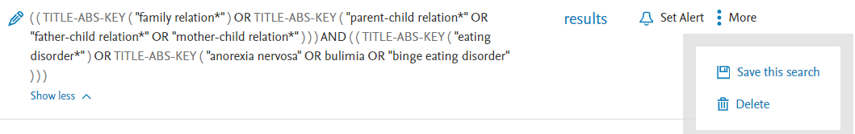
TIP: when you return to Scopus later, sign in before you start searching. Sometimes after signing in, Scopus goes back to the default and deletes your searches.

Searching Scopus – in general

A topic search in Scopus

- Select Documents, on the Document search page of Scopus (this is the default setting)

- Perform a separate search for each element in your research question – this will make it easier to adjust your search later. Use your search profile.
You can add search boxes by clicking + Add search field below the search box. Search terms belonging to the same element are combined with OR, you can select this operator in the dropdown menu between the search bars. You can also enter all search terms in one search box, with OR between them. By default, Scopus searches in the fields ‘Article Title, Abstract, Keywords’. You can change this, but for now, it’s a good start.

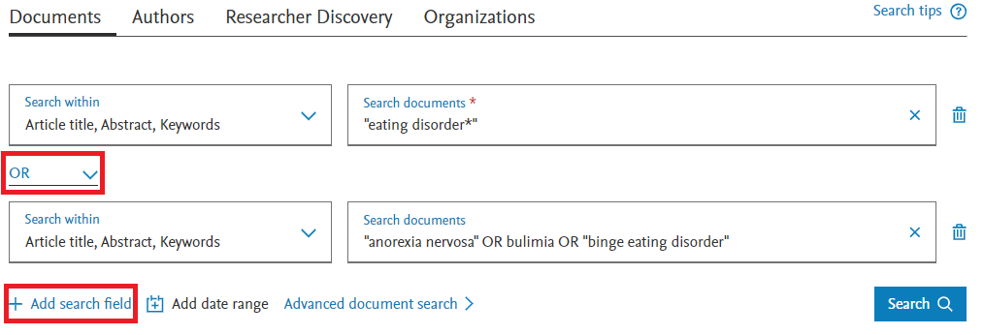

- Click the Search button when you have entered all search terms that belong to one element of your research question.

- Repeat this for the remaining elements of your question: Go back to Search (the easiest way is to click Search at the top of the screen) or use the search bar(s) at the top of the search results. When necessary, empty the search bars (or click Reset) and repeat the steps 2 and 3 for the remaining elements.

- You can now combine these separate searches in the Search History at the bottom of the Search page. Mark the queries and click Combine queries. In the Combine queries box, you can adjust the Boolean operator (if needed; AND is the default). Searches belonging to different elements of the research question are combined with AND.

- Click Show results to perform the search.

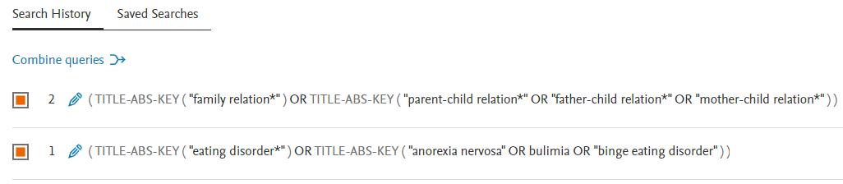
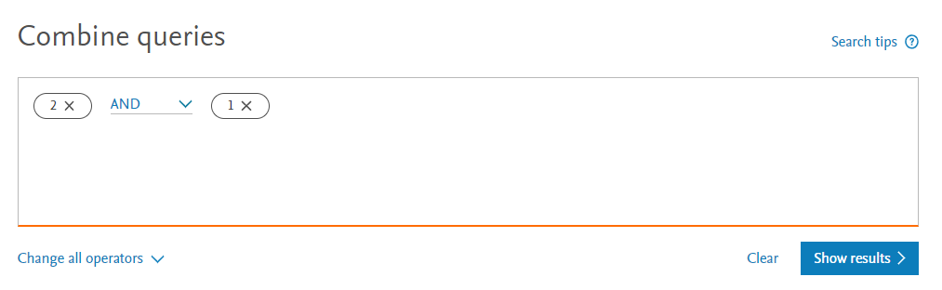

The search results in Scopus

The search results page consists of two parts:
- In the main panel you see the results of your search; for each result you see the title of the article, the author(s), year of publication, the title of the journal in which the article is published and the number of citations the document received from other documents in Scopus.
- The left-hand column presents options you can select to further refine your search, such as by year of publication, author, subject area, document type, language, etc. Mark the options, then choose Limit to (keep in the results) or Exclude (delete from the results). Please note: the Subject Areas are assigned to journals, not to individual articles.

About the search results:
- The most recent articles are on top of the list. You can change the order of results with the option in the right upper corner above the results – for example sort by the number of citations (cited by) or by the name of the first author. When you sort by relevance, Scopus will look, among other things, at how often your search terms occur in the title, abstract and keywords of the article.
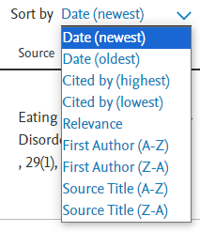

- When you click a title, the document page will appear, with (in most cases) the abstract of the article, the author keywords, etc. After reading the abstract, you decide if you want to read the article.
- If you want to read the full article, there are different ways to get the full-text:
  - Some documents have a View PDF link, below the author information. Scopus shows this link when they know the EUR has access to the article.
  - The Full text options drop down menu shows a link to the website of the publisher and a link ‘Find Full-Text @ EUR’.
  - When you are using Lean Library, you will see a pop-up when the EUR has access to the article.
- You can save interesting and relevant articles in a list. Click the link Save to List. You need an account to use this functionality.
- If the article has been cited by other documents in Scopus, the document page contains a ‘Cited by xxx documents’ box.
- On the document page you can also find ‘Related documents’ within Scopus – this option searches for documents similar to the article, based on an overlap in the reference list, the keywords or the authors.

Adjusting your research question and search profile

When you have a first overview of publications that match your search profile, it is important to evaluate whether your question and the search profile require some adjustments. For example, if your search profile only returns five search results, your question may be too narrow. If, on the other hand, your first search results in more than 5,000 search results, your search was probably too broad. In the latter case you would need to further specify your research question. A good way to do this is by looking at possible interesting subtopics in your search results.
Example: The previous search profile above in the question about the role of families in eating disorders, could focus on the role of families in the treatment of eating disorders – apart from parents we also include siblings. A further possibility for specification is to have the question exclusively related to the eating disorder Anorexia Nervosa. This would result in the following search profile:

Step 2: First analysis of search results in Scopus and adjustment of search profile

Perform a topic search in Scopus with the search profile you have created in Step 1.
- Write down how many results your first search produced: ……………………………………………

- Try different sorting methods and, each time, look at the titles and abstracts of the first 10 search results. Save interesting titles to your list and make a note of additional search terms or interesting subtopics within the results:

- Sort the search results by Date (newest) (that’s normally the default sort order).
- Sort the search results based on the number of citations within Scopus (sort by "Cited by (highest)").
- Sort the search results by Relevance. This is a calculated relevance: how often do the search terms used in the query appear in the document details? The higher the score, the higher the relevance.

Do you see subtopics (like specific population groups or settings) within the results? Write down the subtopics and any synonyms you find. These can be subtopics you want to focus on, but also subtopics you want to exclude form your results. This will help you to focus your research question.

subtopic ................................................
subtopic ................................................
subtopic ................................................
additional search term ................................................
additional search term ................................................ etc.

- The subtopics you find in the search results, can provide ideas for a more specific research question. For example, particular therapies or a specific target group. In that case, you can extend your search with extra search terms, with AND.

Write down your adjusted research question and search profile:
………………………………………………………………………………………………………………………………………………………………………………………………………………………………………………………………………………………………………………………………………………………………………………………………………………………………………………………

Advanced options in Scopus – impact of journal, author, and article

Scopus offers a lot of additional information about the journal an article was published in, about the author who wrote the article (what has (s)he published?) and about the article itself. These options in Scopus help you find the most important journals, authors and articles in the set of documents.

- If you have found interesting subtopics or useful synonyms in the previous assignments, you might want to update your search profile and perform a new search in Scopus.
- To get an overview of your topic, click Analyze results above the list of results. ‘Documents by year’ is the first graph shown. Scroll down the page to see the other options, for example of the documents per year by journal (source), by author, and by affiliation (the universities of the authors).

Journals

- When you click 'Documents per year by source', you get an overview of the journals within your search results.
- Mark the three journals with the highest number of publications. Click the link Compare sources and view CiteScore, SJR, and SNIP data.
- You will see a graphic presentation of the CiteScore per year for the selected journals. The CiteScore is an indicator for the citation impact of the journal. The CiteScore is calculated by the number of citations received by the journal over four years, divided by the number of documents indexed in Scopus and published in the same four years.
- Other indicators in Scopus are the SJR (SCImago Journal Rank), SNIP (Source Normalized Impact per Paper), the citations by year, the number of documents, the percentage of articles not cited and the percentage of review articles (this is important because reviews get more citations than other article types). With this data you can assess the importance of a journal.
- Look at the graph of the CiteScores. When you compare journals from the same subject field, you can compare the numbers you see in the graph. However, when the journals belong to different subject fields, you can’t, because citation patterns differ per subject field (for example the length of the reference lists differs, the age of citations differs, in some fields researchers publish more in books and chapters than in other fields, etc.). Therefore, a CiteScore of 10 can be the top score in one field, but only a median score in another field.
- If you want to compare journals by CiteScores across fields, you have to search the journals in Scopus, by using the option Sources at the top of the screen. There you can find the CiteScore rank – that’s the ranking of the journal within a subject field, based on the CiteScore. For example: the European Eating Disorders Review, using the CiteScore of 2022, is ranked 25 out of 292 journals in the subject area clinical psychology, that’s the 91st percentile.

Authors

- Return to the Analyze search results page. Create an overview of authors by clicking on Documents by author. Which author published the most on your topic?
………………………
- When you click on the name of an author (in the left of the screen), you will see his/her author page ‘Author profile’ within Scopus.

Articles

- Return to the search results. Sort by number of citations (Cited by (highest)). When searching for highly cited articles on Scopus, you'll likely find foundational or influential studies that have shaped a field over time. Are the highly cited documents relevant for your topic?

- Next, sort by publication date (Date (newest)). Recently published articles, are likely to reflect current trends and new discoveries or contributions to the debate about your topic. Are recent documents relevant for your topic?

- Finally, limit your search results to review articles by selecting ‘Review’ under the ‘Document type’ refine option (on the left side of the screen). Again, sort by publication date (Date (newest)). Review articles synthesize existing literature and are likely to provide an overview of the current state of understanding on your topic. Are there any recent review articles relevant for your topic?

Step 3: Further analysis of the search results – impact of journal, author, and article

Perform a topic search in Scopus with the updated search profile.
- Write down how many results your adjusted search produced: ………………

- Select only those papers that were written in English. Write down how many results you have left: ………………………………….

- Create a list of the three (psychological) journals that have published most about your topic, and include their CiteScore of 2023:
- …………………………………. - … documents CiteScore 2023: …
- …………………………………. - … documents CiteScore 2023: …
- …………………………………. - … documents CiteScore 2023: …

- Look at the Author Page of the author that published most about your topic – write down the name and the institution where the author works. Look at their publication list – Is the author important within your topic? (Check for example the most recent publications, how old are these? What is the topic?)
..................................................................................................................................................................................................................................................................................................................................................................................................................................................
- What are the most cited documents in your search results that are relevant to your research question? Save these articles to your list.
Note: these articles are likely to be foundational or influential studies within your topic.

............................................................
............................................................
............................................................

- Sort the search results by publication date (Date (newest)). Check the 15 most recent publications in your list: of these 15, what are the most relevant English-language review articles for your topic? Read the title and abstract. Save these articles to your list.
Note: These articles are likely to reflect current trends and new discoveries or contributions to the debate about your topic.

............................................................
............................................................
............................................................

- Limit the number of results to Review by using the Document type filter. Check the 15 most recent publications in your list: of these 15, what is the most relevant English-language review article for your topic? Read the title and abstract and save it to your list. .............................................................................................................................................................................................................................................................................................
Cited …. times.
Note: Review articles synthesize existing literature and are likely to provide an overview of the current state of understanding on your topic.

Further adjusting your research question and search profile
It could be possible that you are still able to define interesting subtopics that further specify your research question. If the number of search results still allows for a further narrowing of the scope of your search, then you could repeat step 3.

- Too few, too many results?

I have too few results:
- First check for spelling mistakes in your query
- Check the Boolean operators used in your query – have you used AND between the different elements of your query or also within an element?
- Check the articles that are relevant for your topic: can you find synonyms or related terms to expand your search?

I have too many results:
- If you use terms like positive psychology or smoking cessation, you can put them between quotation marks (“). This will make the search more specific – the terms have to be next to each other in the title, abstract or keywords.
- Check the search results for subtopics – maybe you can add an extra element to your research question and focus for example on a particular setting, therapy or population group.
- Check the subject area limit: there you can exclude results from irrelevant subject areas.

Selection of sources

After having performed your topic search in Scopus, you have to select the sources that you would like to use in your report.
- Read the abstracts of the articles you have added to My List to make a judgement on the usefulness of these articles. Select a number of articles that highlight different perspectives on your subject. It is, for example, good to select articles written by different authors.

- Globally read the articles that seem relevant and determine the research question, hypotheses, research method, and conclusions of the article.

- Determine whether the articles are relevant to your research question.

Step 4: Selection of sources
Select +/- 10 sources that you would like to use in your report (this can be a mix of articles provided by your trainer and articles that you have searched yourself).
Note: Your literature report must incorporate at least 5 scientific sources, 3 of which must be empirical articles discussed in the main body of the report. An additional requirement is that you are to have sourced 2 of these articles yourself. Please be aware that 5 sources is the bare minimum. To ensure sufficient depth of content you will need to include about 8-10 sources.

